Pennsylvania Migrant Education Program

Recruiter Manual

Revised May 22, 2026

Table of Contents
The Pennsylvania Migrant Education Program (PA-MEP) 4
History 4
Overview 4
Goal 5
Identification and Recruitment (ID&R) 5
ID&R Overview 5
The Recruiter 5
Core Responsibilities 5
How Recruiters Do the Job 6
Characteristics of an Effective Recruiter 9
Key Professional Practices 9
Time Expectations 10
Safety 10
Time Management (Field Use) 11
Completing the Certificate of Eligibility (COE) 11
COE Completion Principles 11
Key Sections to Get Right 11
Family & Contact Information 11
Qualifying Move 11
Work Information 12
Child Information 12
Comments (Critical Section) 12
Signatures 12
Final Check Before Submission 13
After Submission 13
Paper COEs (If Applicable) 13
COE Mistakes to Avoid 13
COE Comment Examples (Good vs Bad) 14
Appendix 16
MEP Organizational Chart 16
PA-MEP Regions and Project Areas 17
Migratory Child 18
Child Eligibility Checklist 19
Agriculture Crops and Activities in Pennsylvania 20
Sample Intro Script 21
Family Educational Support Survey - Title I, Part C (English) 22
Encuesta de Apoyo Educativo Familiar – Titulo I, Parte C (español) 23
Sondaj Sipò Edikatif pou Fanmi – Title I, Part C (Kreyòl) 24
Dear Agricultural Employer 25
Dear Public School Administration 26
Dear Community Agency, 27
Resources 28
Non-Regulatory Guidance (ESSA) July 1, 2017 28
PA-MEP Quality Control Procedures 28
PA-MEP Memos 28
PA-MEP Brochures 28
MSIX Brochures 28
National IDR Manual 29
Plyler v. DOE (1982) 29
IDRC – Identification & Recruitment Consortium 29
Safety 29

The Pennsylvania Migrant Education Program (PA-MEP)

History
To understand how the PA-MEP developed, it is helpful to look at the origins of Title I of the Elementary and Secondary Education Act (ESEA), previously known as Chapter I.
In Pennsylvania, efforts to support these students began even earlier. Fruit growers – particularly apple growers in Adams County – lobbied state legislators in the late 1950s, leading to the establishment of a state-funded migrant education and childcare program in 1959. These early efforts were driven by concerns for child safety, workforce stability, and overall wellbeing.
At the national level, research in the late 1950s and early 1960s showed a strong link between poverty and low academic achievement. In response, Congress passed Title I of ESEA in 1965 to provide funding to schools serving low-income students, with the goal of improving academic outcomes through supplemental instruction.
In 1966, Congress amended Title I to address the needs of additional underserved groups, including migratory children, establishing what is now the Migrant Education Program (MEP).
The Migrant Education Program is authorized by the following:
- Statute: Elementary and Secondary Education Act (ESEA), Title I, Part C (§1301–1309), as amended by ESSA
- Regulations: 34 CFR §§ 200.81–200.89
- Guidance: PA-MEP Policy and U.S. Department of Education Office of Migrant Education Non-Regulatory Guidance

Overview
Pennsylvania’s Migrant Education Program (PA-MEP) is a federally funded program that supplements educational support services for migratory children. The PA-MEP assists school districts and charter schools in coordinating the continuity of educational services for children who have had their schooling interrupted and provides formula grants to state educational agencies to establish or improve education programs for migratory children.
PA-MEP supplemental services include:
- Early Childhood and Preschool Services: educational support and resources for young children to ensure they are ready for school
- Out-of-School-Time (OST) Programs: after-school and weekend programs to help students with homework, tutoring, and enrichment activities
- Summer School: additional learning opportunities during the summer to help students catch up or get ahead in their studies
- Out-of-School Youth (OSY): educational and career support for youth who are not currently enrolled in school and have not yet graduated or received a GED
- Credit Accrual: student assistance to earn credits towards graduation through various educational programs and initiatives
- Student Leadership/Special Projects: leadership activities and special projects to develop students’ skills and interests
- Diploma Project Toolkit: resources and tools to help students complete their high school education and earn their diploma

Goal
The primary goal of the Migrant Education Program is to ensure that all migratory children and youth reach challenging academic standards and graduate with a high school diploma that prepares them for responsible citizenship, further learning, and productive employment.

Identification and Recruitment (ID&R)

ID&R Overview
Identification and Recruitment (ID&R) is the process of:
- Finding children and youth who may qualify for the program
- Determining if they meet eligibility requirements
- Completing required documentation (COE) so services can begin
Because families may move frequently and stay for short periods, timely and accurate ID&R is critical to ensuring eligible students are not missed.

The Recruiter

Core Responsibilities
Recruiters are responsible for identifying eligible children and ensuring they are connected to services quickly and accurately.
The Role of the Recruiter:
- Identify potential eligible families
- Conduct interviews to determine eligibility
- Complete accurate Certificates of Eligibility (COEs)
- Build trust with families
- Connect students to the program

How Recruiters Do the Job

PHASE 1: Prepare to Recruit
Before beginning field work, recruiters must be ready to make accurate eligibility decisions.
You must:
- Complete required recruiter training
- Understand eligibility requirements
- Know how to explain the program clearly
- Become familiar with your recruitment area
Goal: Be prepared to identify eligibility correctly the first time

PHASE 2: Build and Maintain a Recruitment Network
Recruiters do not find families by chance—they find them through relationships.
Develop and maintain contacts with:
- Employers (farms, dairies, processors, etc.)
- Schools and school staff
- Community organizations and agencies
- Housing sites, camps, and local businesses
Use your network to:
- Identify new families quickly
- Confirm movement and work patterns
- Increase trust and access to communities
Goal: Know where families are before you go looking

PHASE 3: Identify and Locate Families
Once your network is in place, begin finding potential families.
You should:
- Follow up on referrals and leads
- Visit known housing and work locations
- Track seasonal patterns in your area
- Prioritize newly arrived families
Goal: Find families as soon as possible after arrival

PHASE 4: Recruit and Determine Eligibility
STEP 1: Determine Student Eligibility (Quick Screen)
Before beginning a full interview, confirm:
- Child is under 22 and has not graduated (US)
- A move occurred within the last 36 months
- The move was due to economic necessity
- The family moved to a new residence across school district lines
- The worker engaged in or actively sought agricultural or fishing work
If all are true → Continue to interview
If unclear → STOP and seek guidance

STEP 2: Conduct the Interview
The interview gathers the information needed to determine eligibility.
During the interview:
- Introduce yourself and the program clearly
- Ask key questions about the move, work, and household
- Verify details (dates, locations, work type)
- Ask follow-up questions when needed
Focus on:
- Why the family moved (economic necessity)
- Type of work sought or obtained
- Who moved, when, and how

STEP 3: Complete the COE
The COE is the official legal record of eligibility.
When completing the COE:
- Enter all information accurately
- Ensure move, work, and dates align
- Include only eligible children
- Write clear comments explaining eligibility
Important:
- Comments must explain how and why the family qualifies
- Do not leave gaps or make assumptions

STEP 4: Obtain Signatures
Follow correct order:
- Interviewee signs first
- Recruiter signs after
  - Ensure signatures are complete
  - Document any issues in comments

STEP 5: Submit the COE
Before submitting:
Final Check:
- Move, work, and dates match
- Comments clearly explain eligibility
- No required fields are missing
Then:
- Submit within 24 hours of the family sign date

STEP 6: Follow Up
Recruitment continues after submission.
You are responsible for:
- Responding quickly to corrections or questions
- Providing additional information if requested
- Tracking approval status
Goal: Ensure COE moves to approval without delay

Characteristics of an Effective Recruiter
Strong recruiters develop their skills over time. No one starts with everything—but the most effective recruiters consistently demonstrate the following:
Effective recruiters:
- Make accurate eligibility decisions
- Document clearly and completely
- Manage time and workload effectively
- Work independently and stay organized
- Adapt to changing situations in the field
- Build trust with families and community contacts
- Ask strong questions during interviews
- Maintain professionalism, confidentiality, and integrity
- Show cultural awareness and respect
Bottom line: Accuracy, consistency, and trust are the foundation of successful recruitment.

Key Professional Practices
Know Your Program
- Understand available services
- Be able to clearly explain the program to families
- Never promise services, timelines, or outcomes you or the program cannot deliver
Build and Use a Network
- Maintain connections with employers, schools, and community agencies
- Use contacts to identify families quickly
Ask Questions
- Seek guidance when unsure
- Never guess on eligibility
Stay Objective
- Base decisions on eligibility rules—not personal opinion
Work as a Team
- Use coordinators and state staff for support
- Recruitment is not done alone
Honor Commitments
- Consistently follow through on what was communicated to contacts to build trust, credibility, and ongoing collaboration

Time Expectations
- At least 90% of work time must be spent on recruitment activities
- Prioritize locating families, interviewing, and completing COEs

Safety
For full safety procedures and detailed guidance, please refer to the complete Safety section in the Resources.
Before Visits
- Plan route and inform team
- Check phone and vehicle
During Visits
- Assess surroundings
- Trust your instincts—leave if unsafe
- Always carry identification
After Visits
- Report concerns
- Document incidents

Time Management (Field Use)
- Schedule visits when possible
- Group routes and visits by location
- Allow time after each visit for documentation
- Plan around work schedules and seasons

Completing the Certificate of Eligibility (COE)
The COE is the official legal record of a student’s eligibility. It must be completed accurately and fully for the student to receive services.
All COEs must be entered into the official system unless otherwise directed.
The MIS2000 database stores all COEs. COES must be retained for 11 years.

COE Completion Principles
Every COE must be:
- Complete (no blank required fields)
- Accurate (no assumptions or guesses)
- Consistent (all sections align)
- Clear (comments explain eligibility)
- Errors or missing information will delay approval and services

Key Sections to Get Right
Focus on the areas that most often result in errors:

Family & Contact Information
- Enter all names accurately (no assumptions)
- Verify address, phone, and language
- Use “N/A” where appropriate—do not leave blanks

Qualifying Move
- Clearly document from → to location
- Ensure move meets all eligibility requirements
- Confirm dates are accurate and consistent
Do not confuse:
- Most recent move
- Qualifying move

Work Information
- Must be agricultural or fishing work
- Must be temporary or seasonal
- Must be tied to economic necessity
Include:
- Crop or activity
- Type of work performed or sought
- Whether work was obtained or actively sought

Child Information
- Enter full legal name (no assumptions)
- Verify date of birth using documentation when possible
- Record school, grade, and enrollment correctly
Incorrect birthdates create duplicate records—always confirm

Comments (Critical Section)
Comments must clearly explain how and why the family qualifies. A reviewer should be able to understand eligibility without asking questions.
Additional comments are required when:
- The situation is unusual or unclear
- “Actively sought” is used
- “To join” or “prior to” situations
- Work or move could be misunderstood
- Temporary statements
Weak or vague comments are the #1 reason COEs are rejected

Signatures
- Interviewee must sign first
- Recruiter signs after
- Signatures must be complete and dated
If a signature issue occurs, document it in comments.

Final Check Before Submission
Before submitting, confirm:
- Move, work, and dates align
- All required fields are complete
- Comments clearly explain eligibility
- No assumptions were made
Then submit within required timeline

After Submission
Recruiters are responsible for:
- Responding to correction requests
- Providing additional information if needed
- Monitoring COE status until approved

Paper COEs (If Applicable)
If a paper COE is used:
- Complete all fields clearly and fully
- Do not leave blanks
- Submit for entry into the system as soon as possible
- Maintain confidentiality and secure storage at all times

COE Mistakes to Avoid
Avoiding these common mistakes will prevent delays, corrections, and rejected COEs.
Most common errors:
- Vague comments
  - Writing “moved for work” or “works on farm” without explanation
- Missing economic necessity
  - Not clearly stating why the move happened
- Weak work description
  - No crop, activity, or type of work listed
- Incorrect or mismatched dates
  - Move dates, work dates, and arrival dates don’t align
- Confusing the qualifying move
  - Using the most recent move instead of the qualifying move
- Including ineligible children
  - Not verifying age, graduation status, or move connection
- Assuming instead of asking
  - Filling in missing information without confirming
- Not documenting “actively sought” work
  - Failing to explain job search and work history
- Weak “to join” or “prior to” explanations
  - Not explaining timing differences between worker and child moves
- Submitting without a final review
  - Skipping the final accuracy check before submission
Reminder: Most COE rejections are due to comments and incomplete explanations—not missing fields.

COE Comment Examples (Good vs Bad)
Strong comments clearly explain how and why the family qualifies.

GOOD: Standard Qualifying Move
“Family moved from TX to PA on 3/1/2025 due to lack of work. Father obtained seasonal work picking apples within 2 weeks at ___ Orchard.”
Includes:
- Clear move
- Economic need
- Type of work
- Timeline

GOOD: Actively Sought Work
“Worker moved to PA on 4/10/2025 seeking agricultural work. Applied at multiple farms but was not hired due to wet weather delaying planting. Has history of seasonal farm work. Moved from OH to PA 4/9/2024 and planted evergreen cuttings. Also moved from IN to OH 9/1/2023 to harvest beets. ”
Explains:
- Job search
- Timeline
- Work history

GOOD: To Join Scenario
“Children moved from FL to PA on 5/1/2025 to join father who moved on 2/5/2025 for mushroom harvesting work. Children remained behind to finish school year.”
Explains:
- Why move timing differed
- Connection to worker

GOOD: Temporary Work
“Family moved to PA on 8/15/2025 for temporary tomato packing work expected to last 2–3 months based on employer need.”
Explains:
- Temporary nature of work
- Expected duration

BAD: Too Vague
“Moved for work.”
Missing everything needed to determine eligibility

BAD: Weak Work Description
“Works on a farm.”
Missing:
- Crop
- Activity
- Type of work

BAD: Incomplete Explanation
“Came to join husband.”
Missing:
- Why and when the husband moved
- Were the moves within one year of each other

Bottom Line for Recruiters
Every comment should clearly and concisely explain why the students are eligible for the PA-MEP.

Appendix

MEP Organizational Chart

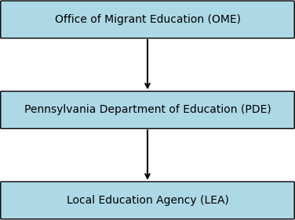

PA-MEP Regions and Project Areas
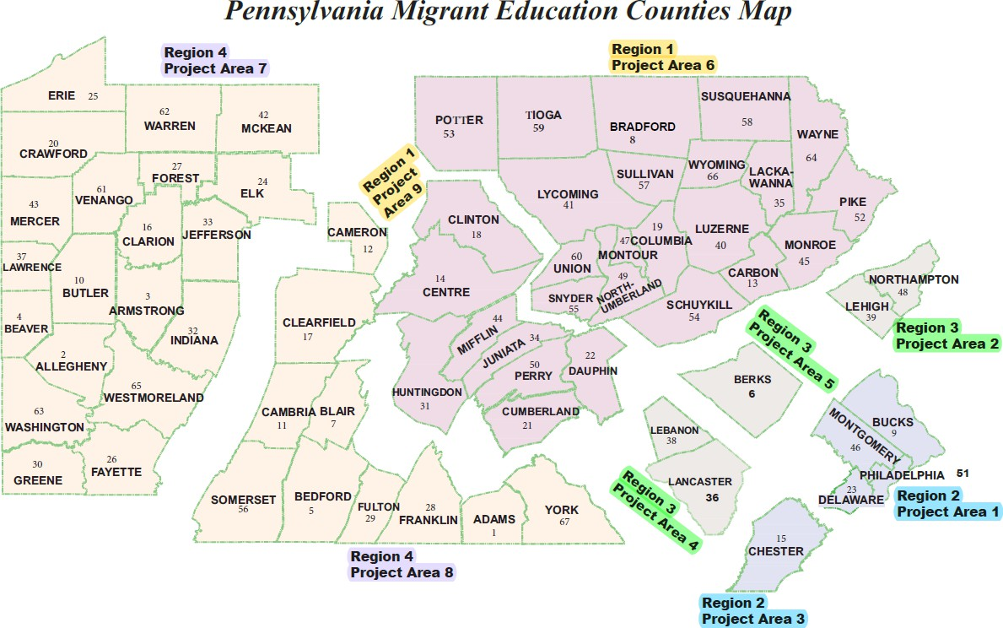

Migratory Child
According to sections 1115(c)(1)(A) (incorporated into the MEP by sections 1304(c)(2), 1115(b), and 1309(3) of the ESEA, and 34 C.F.R. § 200.103(a)), a child is a “migratory child” if the following conditions are met:
- The child is not older than 21 years of age; and
- The child is entitled to a free, public education (through grade 12) under State law, or the child is not yet at a grade level at which the LEA provides a free public education, and
- The child made a qualifying move in the preceding 36 months as a migratory agricultural worker or a migratory fisher, or did so with, or to join a parent/guardian or spouse who is a migratory agricultural worker or a migratory fisher; and
- Regarding the qualifying move identified in paragraph 3, above, the child moved due to economic necessity from one residence to another residence, and—
- From one school district to another; or
- In a State that is comprised of a single school district, has moved from one administrative area to another within such district; or
- Resides in a school district of more than 15,000 square miles and migrates 20 miles or more to a temporary residence.

Child Eligibility Checklist
CHILD ELIGIBILITY CHECKLIST FOR THE MIGRANT EDUCATION PROGRAM
This checklist is intended to be a tool to determine if a child meets the basic eligibility factors of the MEP. It does not take into account all information necessary to complete a COE and document eligibility for the MEP.
FACTOR 1: CHILD’S AGE
◻ The child is younger than 22 years old on the date of the interview.
FACTOR 2: CHILD’S SCHOOL COMPLETION STATUS
- The child is entitled to a free public education through grade 12 under state law, OR
- The child is not yet at a grade level at which the school district provides a free public education.
FACTOR 3a: CHILD’S QUALIFYING MOVE | FACTOR 3b: CHILD’S QUALIFYING MOVE RELATIVE TO THE MIGRATORY AGRICULTURAL WORKER OR MIGRATORY FISHER
The child moved within the 36 months preceding the date of the interview  - due to economic necessity, AND  - from one residence to another residence, AND  - from one school district to another. | - The child’s QUALIFYING MOVE in FACTOR 3a was as a migratory agricultural worker or migratory fisher, or was made with, to join or to precede a parent, guardian, or spouse who is a migratory agricultural worker or a migratory fisher (as determined in Factors 4a and 4b).
FACTOR 4a: MIGRATORY AGRICULTURAL WORKER’S OR MIGRATORY FISHER’S QUALIFYING MOVE | FACTOR 4b: QUALIFYING WORK FOR THE MIGRATORY AGRICULTURAL WORKER OR MIGRATORY FISHER
The parent/guardian/spouse or child (if the child is the worker) moved within the 36 months preceding the date of the interview  - due to economic necessity, AND  - from one residence to another residence, AND  - from one school district to another. | After the QUALIFYING MOVE in Factor 4a, the parent/guardian/spouse or child (if the child is the worker)  - engaged in new QUALIFYING WORK (QW) soon after the move, OR  - did NOT engage in new QW soon after the move, but he or she  - actively sought new QW, AND  - has a recent history of moves for QW.  AND  The work is  - seasonal employment, OR  - temporary employment, OR  - for personal subsistence. AND  The work is  - agricultural OR  - fishing.

Agriculture Crops and Activities in Pennsylvania
Activities
Bagging | Baling | Banding | Bedding | Blood Testing | Boxing
Breeding | Bucking | Canning | Catching | Chopping | Classifying
Cultivating | Cutting | Deboning | Digging | Eviscerating | Extracting
Falling | Feeding | Fencing | Fertilizing | Freezing | Gathering
Grading | Grinding | Hanging | Hatching | Hauling | Hoof trimming
Inseminating | Irrigating | Juicing | Killing | Loading | Logging
Marking | Milking | Mixing | Mulching | Packing | Peeling
Planting | Plucking | Potting | Preserving | Pruning | Pulling
Raking | Refrigerating | Rooting | Scalding | Scaling | Seeding
Sexing | Shearing | Skidder Operating |  | Skinning | Slaughtering
Soil preparing | Sorting | Spawning Suckering |  | Tagging | Taking Temperature
Tending | Thinning | Towing Transplanting |  | Trimming | Tying
Vaccinating | Washing | Watering Weeding |  | Weighing | Wrapping
Crops
Apple Trees | Apples | Asparagus | Avocados | Barley | Basil
Bean Sprouts | Beans | Beef | Blackberries | Blueberries | Broccoli
Brussels Sprouts |  | Bulbs | Cabbage | Calf | Carrots
Cauliflower | Celery | Cherries | Cherry Trees | Chicken | Christmas Trees
Corn | Cotton | Cows | Cranberries | Cucumber | Dairy
Deer | Duck | Egg Plant | Eggs | Embryo | Evergreen Cuttings
Evergreen Trees |  | Fish | Flowers | Goats | Grape Cordon
Grapes Greenhouse Bulbs Greenhouse Flowers Greenhouse Plants
Hay | Hemp | Herbs | Horses | Kale | Kiwi Berries
Lettuce | Logs | Melons | Milk | Molasses | Mushrooms
Nectarines | Nuts | Oats | Onions | Oranges | Oyster
Peach Trees | Peaches | Pear Tree | Pears | Peppers | Pig
Pineapples | Plantains | Plum Tree | Plums | Pork | Potato
Pumpkin | Roses | Rye | Sap | Seeds | Sheep
Shrubs | Sod | Sorghum | Soybeans | Spinach | Squash
Straw | Strawberries | Sunflower | Switchgrass | Tobacco | Tomato
Trees Other | Turkey | Veal | Watermelon | Wheat

Sample Intro Script

“Hello, my name is ____. I work with an educational support program that helps families, children, and young adults.
We provide free services like tutoring, homework help, and summer programs, and we partner with local schools to support students and connect families to resources.
This program is offered through the Pennsylvania Department of Education, and we work here in ____.
Here are my card and ID. Can I please have a few minutes to share more?

Family Educational Support Survey - Title I, Part C (English)
These questions help determine if you and/or your children may qualify for additional educational support services. Your information is confidential.

Have you or your family moved in the past 3 years?
☐ Yes ☐ No
Has anyone in your household worked in any of the following types of job?
☐ Yes ☐ No
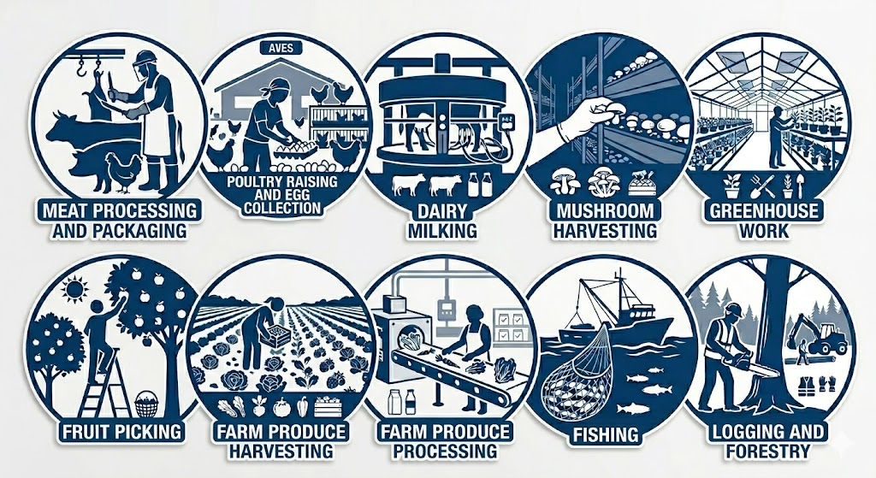
Parent/Guardian Name(s):______________________________________________
Phone Number:_________________________________________________________
Address:_______________________________________________________________
Ages of child(ren):______________________________________________________
Preferred Time to Contact:
☐ Morning ☐ Afternoon ☐ Evening ☐ Weekend

Encuesta de Apoyo Educativo Familiar – Titulo I, Parte C (español)
Estas preguntas ayudan a determinar si usted y/o sus hijos pueden calificar para servicios adicionales de apoyo educativo. Su información es confidencial.

¿Usted o su familia se han mudado en los últimos 3 años?
☐ Sí ☐ No
¿Alguien en su hogar ha trabajado en alguno de los siguientes trabajos?
☐ Sí ☐ No
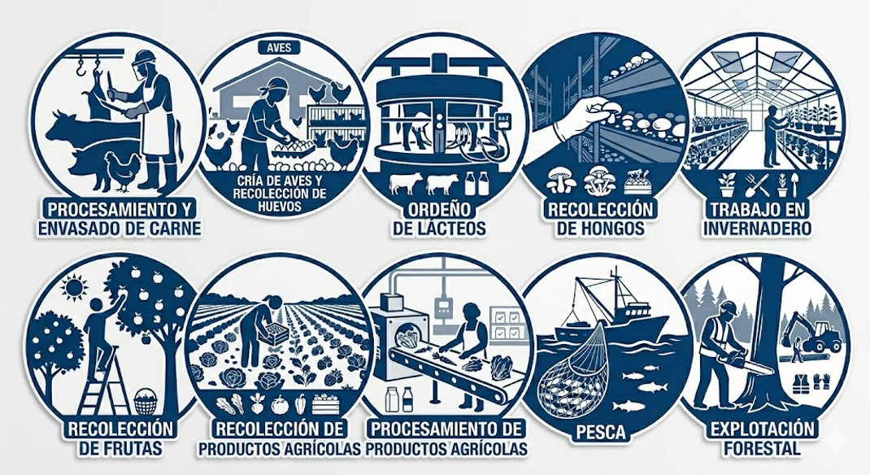
Nombre del padre/madre o tutor: _______________________________________
Número de teléfono: ___________________________________________________
Dirección: ______________________________________________________________
Edades de los niños: ____________________________________________________
Hora preferida para ser contactado(a):
☐ Mañana ☐ Tarde ☐ Noche ☐ Fin de semana

Sondaj Sipò Edikatif pou Fanmi – Title I, Part C (Kreyòl)

Kesyon sa yo ede detèmine si ou menm ak/oswa pitit ou yo ka kalifye pou sèvis sipò edikatif anplis. Enfòmasyon ou bay yo ap rete konfidansyèl.

Èske ou oswa fanmi ou te deplase nan 3 dènye ane yo?
☐ Wi ☐ Non
Èske gen nenpòt moun nan kay ou ki te travay nan youn nan kalite travay sa yo?
☐ Wi ☐ Non

Non Paran/Gadyen: _____________________________________________
Nimewo Telefòn: ________________________________________________
Adrès: __________________________________________________________
Laj timoun yo: __________________________________________________
Lè ki pi bon pou kontakte ou:
☐ Maten ☐ Apremidi ☐ Aswè ☐ Fen semèn

April 2, 2026
Dear Agricultural Employer,
Thank you for the hard work you do every day to make Pennsylvania’s agriculture strong. Your dedication plays a vital role in feeding our communities, and we truly appreciate it.

Whether this letter is in your mailbox or is being handed to you by a local recruiter, we greatly appreciate a moment of your time to share information about the Pennsylvania Migrant Education Program (PA-MEP).

This program, under the Pennsylvania Department of Education and the Center for Schools and Communities, is delivered in partnership with local agencies including Northwest Tri-County Intermediate Unit, Central Susquehanna Intermediate Unit, Chester County Intermediate Unit, and Millersville University.

Our goal is simple: to ensure that mobile agriculture workers and their families have the same opportunities to learn and thrive as all students. Services may include:
- Summer and after-school programs
- In-home tutoring
- Help with school enrollment and immunizations
- Parent involvement activities

These free services can benefit families and, in turn, help your business and employees.

If you have questions or would like more information, please contact us at 717-224-1413 or visit: https://www.education.pa.gov/K-12/Migrant%20Education/Pages/default.aspx

Sincerely,

Deke A. Showman
State Recruitment Supervisor
Cell: 717-224-1413
Email: dshowman@csc.csiu.org

April 2, 2026
Dear Public School Administration,
The Migrant Education Program, Title I, Part C of the Every Student Succeeds Act, provides supplemental educational support and instructional services to migratory children and their parents or guardians. Examples of the support and instruction the program provides include summer programming, afterschool programs, in-home tutoring, school enrollment, scheduling required school immunizations, and parent involvement. There are no costs to schools, employers, or families and all student information is protected under FERPA.
In order to qualify for services, children must have moved across school districts in the last three years with, to join, or as a migratory agricultural worker. There are complex eligibility situations and for this reason, only highly trained Migrant Education Program Recruiters can determine student eligibility.
The Pennsylvania Migrant Education Program serves migratory students and families in every Pennsylvania county.
The Local Education Agencies that serve migratory students are: Central Susquehanna Intermediate Unit, Chester County Intermediate Unit, Millersville University, and Northwest Tri-County Intermediate Unit
We are including a letter from our PDE Bureau Chief, flyer with information about the Migrant Education Program, and a referral form your district can use if you have any students you feel may qualify for services.
We wish the best for your schools this year and please contact us if you have any questions about the Migrant Education Program.
Sincerely,
Deke A. Showman
MEP State Recruitment Supervisor
Center for Schools and Communities
275 Grandview Avenue, Suite 200
Camp Hill, PA 17011
717-224-1413
March 31, 2026

Dear Community Agency,

Thank you for the important work you do to support children, youth, and families across Pennsylvania. Your organization plays a vital role in connecting families to essential services, and we appreciate your commitment to the communities you serve.

We are writing to share information about the Pennsylvania Migrant Education Program (PA-MEP)—an educational support program under the Pennsylvania Department of Education and the Center for Schools and Communities. Through partnerships with local agencies, PA-MEP works to ensure children from mobile agricultural families have access to educational opportunities that promote stability and academic success.

PA-MEP provides free educational support services to eligible children and families, which may include:
- Summer and after-school programs
- Tutoring and academic support
- Assistance with school enrollment, records, and immunizations
- Parent engagement activities

Because some families you serve may also be eligible for PA-MEP, we invite collaboration through information-sharing and referrals. Enclosed is our referral form for use when you identify families who may benefit. We also provide families with information about community agencies and encourage them to pursue additional support as needed.

If you have questions or would like to discuss collaboration, please contact me any time.

Thank you for your partnership and continued service to Pennsylvania families.

Sincerely,

Deke A. Showman
State Recruitment Supervisor
Cell: 717-224-1413
Email: dshowman@csc.csiu.org

Resources

Non-Regulatory Guidance (ESSA) July 1, 2017
The Non-Regulatory Guidance is a federal document that helps states and local programs interpret and apply MEP requirements. It offers clear explanations and practical examples on eligibility, recruitment, and services to ensure migratory students are properly identified and supported.

PA-MEP Quality Control Procedures
The PA-MEP Quality Control Procedures outlines the standardized processes and safeguards used to ensure accurate eligibility determinations, consistent identification and recruitment practices, and ongoing monitoring to maintain program integrity across Pennsylvania.

PA-MEP Memos
PA-MEP Memos provides official guidance, clarifications, and updates that support consistent implementation of policies and procedures, helping recruiters stay informed and aligned with state expectations.

PA-MEP Brochures
Informational materials that describe the Migrant Education Program and the services available to support eligible students and their families.

MSIX Brochures
Informational materials that explain the purpose of MSIX and how student records are securely shared to support continuity of education for migratory students.

National IDR Manual
The National ID&R Manual is a comprehensive guide that supports consistent identification and recruitment of eligible migratory children. It provides standardized definitions, procedures, and examples to help recruiters accurately determine eligibility and document cases in alignment with federal expectations.

Plyler v. DOE (1982)
Plyler v. Doe is a U.S. Supreme Court decision that guarantees all children, regardless of immigration status, the right to access a free public K–12 education. It ensures that schools cannot deny enrollment based on a child’s or family’s immigration status, supporting equal access to education.

IDRC – Identification & Recruitment Consortium
The IDRC website is an online hub that provides tools, training, and resources to support the effective identification and recruitment of eligible migratory students. It helps MEP staff improve accuracy, share best practices, and connect with materials that strengthen ID&R efforts nationwide.

Safety
Thid document provides safety guidance for recruiters, including detailed protocols, expectations, and best practices for maintaining personal safety in the field.

